Experiment 9: write a Python program to solve the Travelling Salesman Problem.

Aim
To write a Python program to solve the Travelling Salesman Problem.

Algorithm
- Define the distance matrix.
- Generate all possible routes.
- Calculate the total distance of each route.
- Find the route with the minimum cost.
- Display the shortest path and its cost.

Program
from itertools import permutations

graph = [[0,10,15,20],
[10,0,35,25],
[15,35,0,30],
[20,25,30,0]]

cities = [1,2,3]
min_cost = float('inf')

for path in permutations(cities):
cost = graph[0][path[0]]
for i in range(len(path)-1):
cost += graph[path[i]][path[i+1]]
cost += graph[path[-1]][0]

if cost < min_cost:
min_cost = cost
best = path

print("Minimum Cost:", min_cost)
print("Best Path: 0 ->", " -> ".join(map(str,best)), "-> 0")

Output

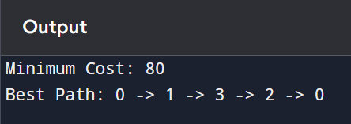

Result
Thus, the Travelling Salesman Problem was solved successfully.

